[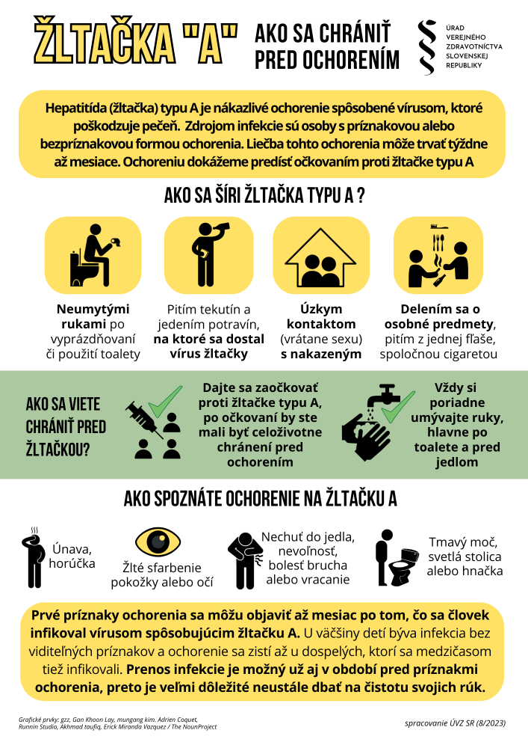](https://www.uvzsr.sk/documents/d/uvz/ztacka-a-4-10-2023-png)