Unemployment in Slovakia
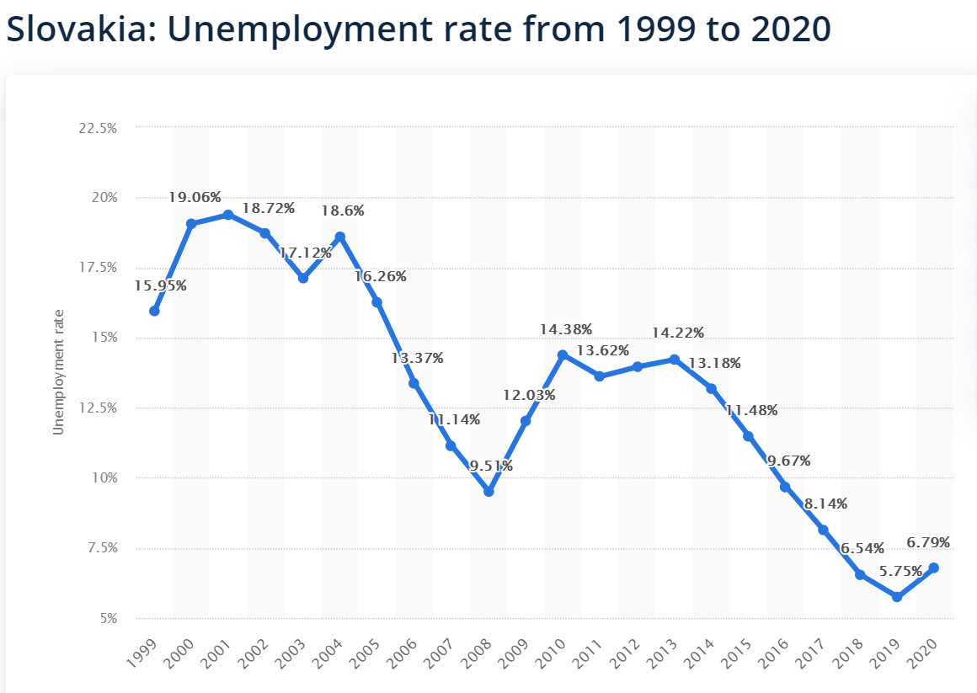

Task 1:
Find the web page and translate
Ministerstvo práce, sociálnych vecí a rodiny
________________________________________________
Write name of the minister: ________________________
Notes:
- The Ministry of Labour, Social Affairs and Family of the Slovak Republic is responsible for employment support, social care and functioning of the pension scheme.
- The role of the Ministry of Labour, Social Affairs and Family of the Slovak Republic is to continually modernize labour legislation with the aim of increasing employment.
- Employment services are provided by:
1. state providers /štátni poskytovatelia služieb zamestnanosti/
  - Central Office of Labour, Social Affair and Family/Ústredie práce, sociálnych vecí a rodiny
  - Local Labour Office, Social Affairs and Family /Úrad práce,....
2. non-state providers /neštátni poskytovatelia služieb zamestnanosti/
  - employment agencies
Illegal work and illegal employment
- have a negative impact on employees, the business environment and society as a whole.
- Persons who work illegally are exposed to problems with their right to wages, meals, the maximum number of working hours, minimum duration of rest or vacation. Later, they may also have problems when claiming a pension.

Task 2: Find web page of Central Office of Labour, Social Affairs and Family.
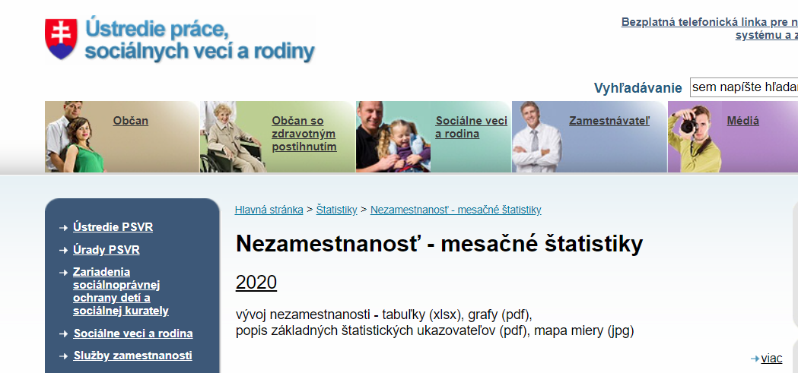

Complete the charts
