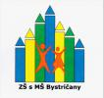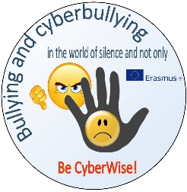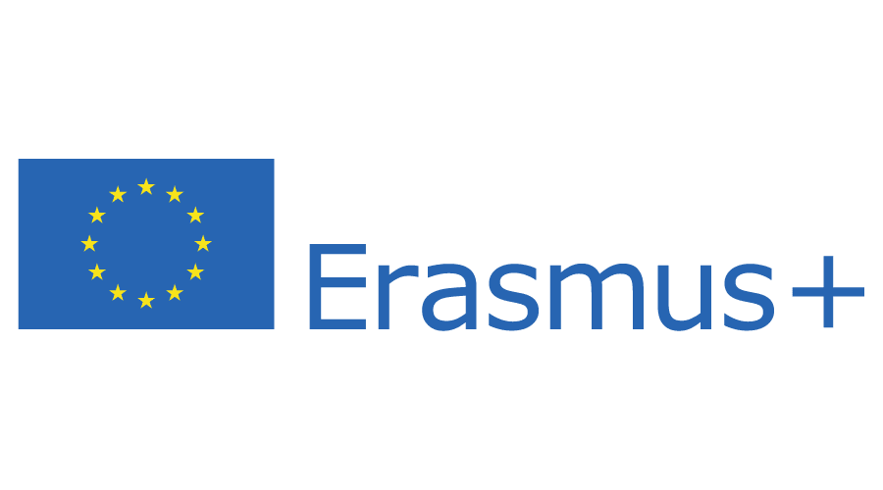

Erasmus+ Programme – Strategic Partnership
Project Code 2020-1-RO01-KA229-080106
Project Title Bullying and cyberbullying in the world of silence and not only – BE CYBERWISE!
Project Acronym BE CYBERWISE!
Submission ID 1646875

Activity report
1.11.2020 – 31.12.2021
I confirm that our organisation Primary school with kindergartner, Mirka Nešpora 12/1, Bystričany 972 45, Slovakia has done these activities until December 31, 2021:
November – December 2020 – preparing the managment of the project
- establishment of the project team and their responsibilities
- participating in whats app group for a good communication
- participating in facebook project page
- making leaflets, brochure and flyers about the ptoject and Erasmus+ programme with students
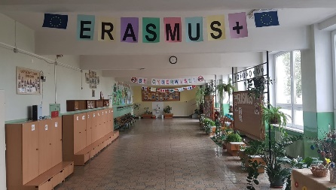
- dissemination of the leaflets about project and Erasmus+ programme to students, teachers, parents
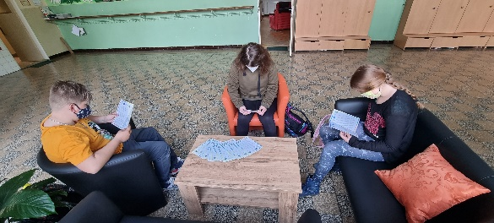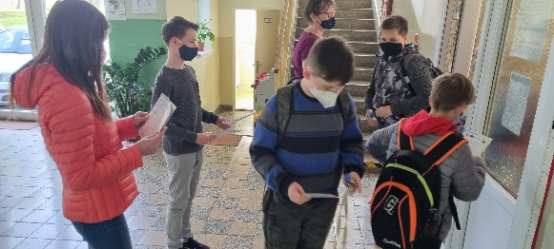

- designing the project logo for logo competition (not winning)
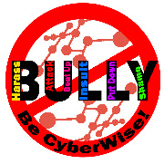
- making presentations about our school, region and Slovakia for Etwinning site (22.11.2020 – Etwinning website)
- making posters and promoting the project and Erasmus+ at the Municipality Office
- promoting the project and Erasmus+ programme on Municipality Office´s facebook page
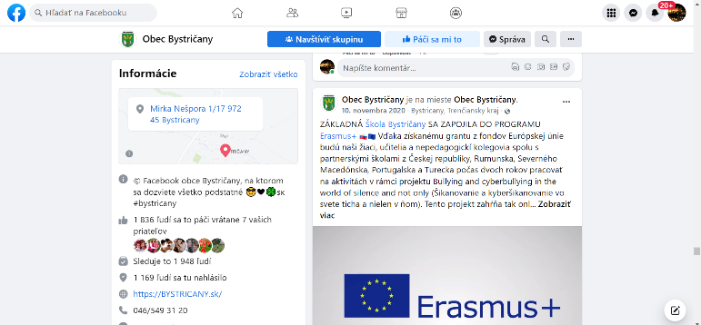
- organizing Erasmus+ and project corner
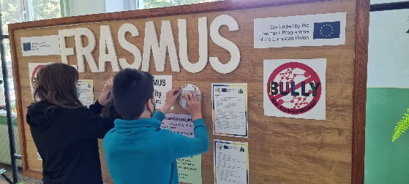
- 1st video-conference of the project teams via Zoom (21.12.2020)
- dissemination of the conference results among teachers and students (13.1.2021)
January - August 2021 – meeting with Municipal Office representative about preparing the 1st camp in Slovakia, promoting the project and Erasmus+
- organizing meeting with the representative of the Police department and discussion about bullying, cyberbullying and their consequences (13.5.2021)
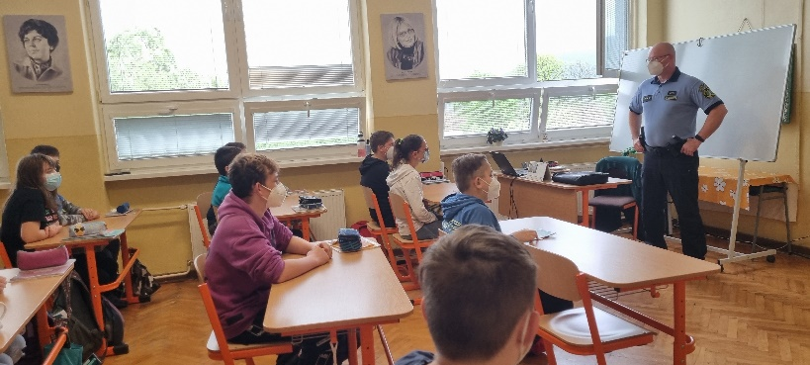
- making and organizing questionnaire about bullying and cyberbullying at our school (May 2021)
- selection of teachers participating in the training course in North Macedonia (March 2021)
- linguistic, theoretical and cultural preparations of teachers for North Macedonia (March – June 2021)
- selection of teachers and students participating in the 1st camp in Slovakia (all teachers)
- linguistic, theoretical and cultural preparations of students for the 1st camp in Slovakia (January – August 2021)
- making the student´s journey diary for the 1st camp in Slovakia
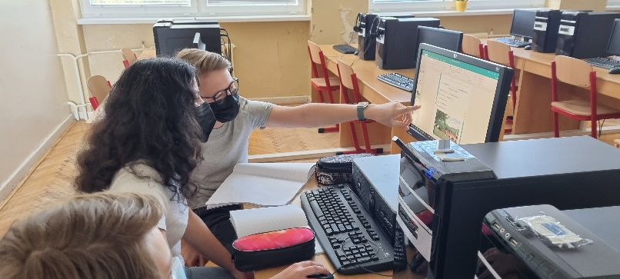
- preparing and establishing the 1st camp in Slovakia
- participating in video-conferences and dissemination of the results to Erasmus+ team and teachers
- writing an article about Erasmus+ programme and project in School Yearbook (https://cloud2h.edupage.org/cloud?z%3AHI7ouSfL2YVNmBqdlPV1Ul3hrDAkclRLFhOXej5k09hpH%2BfRmtv0pN%2BWUzFInTXB – page 17)
September – October 2021 - participating in video-conferences and dissemination of the results to Erasmus+ team and teachers
– participating at the training course in North Macedonia (https://www.zsbystricany.sk/text16/ )
- dissemination of the trainig course results in North Macedonia with students, teachers and parents (16.9.2021)
- organizing the 1st camp for students in Slovakia
( https://www.zsbystricany.sk/text16/ )
- making short films about victims´ confessions
- making film about the 1st camp in Slovakia
- dissemination of the 1st camp results in Slovakia with students, teachers and parents (2.11.2021)
November - December 2021 – making the newspapers about the 1st camp in Slovakia (22.11.2021)
- participating in Europass and Epale web course – project team members (23.11.2021)
- writing the year report to National Agency (29.11.2021)

1.1.2022 – 31.07.2022
January – March 2022 - selection of teachers and students participating in the 2st camp in Portugal (January 2022)
- linguistic, theoretical and cultural preparations of students for the 2st camp in Portugal (January – March 2022)
- participating in the 2nd questionnaire about bullying and cyberbullying made by Portugal ( March 2022)
- participating in video-conferences and dissemination of the results to Erasmus+ team and teachers
- preparing the travel and participation in the 2nd camp in Portugal
April – May 2022 - participating in video-conferences and dissemination of the results to Erasmus+ team and teachers
– participating in the 2nd camp in Portugal
( https://www.zsbystricany.sk/text16/ )
- writing the stories about dramas filmed during the 2nd camp
- dissemination of the camp results among students, teachers, parents
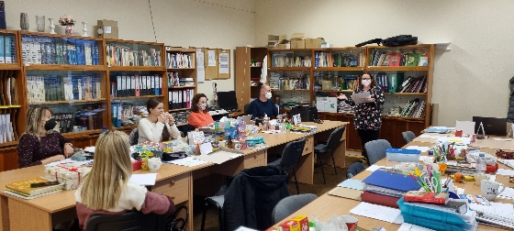
- selection of teachers participating in the final transnational meeting in Romania ( April 2022)
- linguistic, theoretical and cultural preparations of teachers for the final transnational meeting in Romania (April – June 2022)
- making the presentation about the project for the international conference in Romania (May 2022)
June 2022 – participating in the final transnational meeting in Romania
( https://www.zsbystricany.sk/text16/ )
- participating in the international conference in Romania
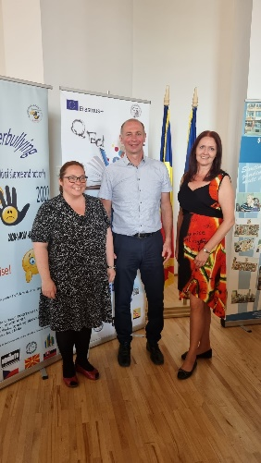
- dissemination: writing an article about Erasmus+ programme, project and the results in School Yearbook (June 2022)
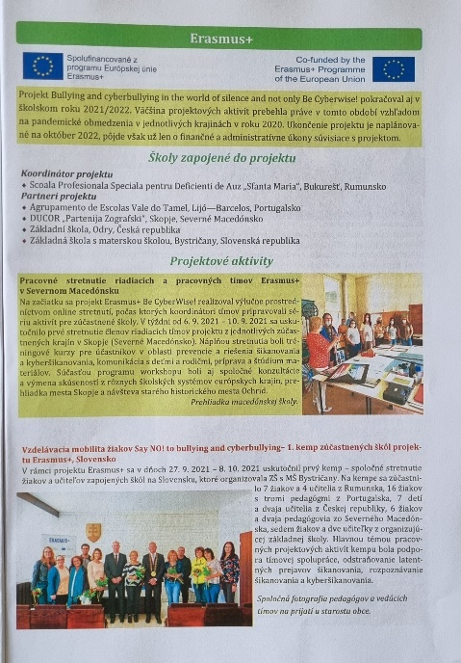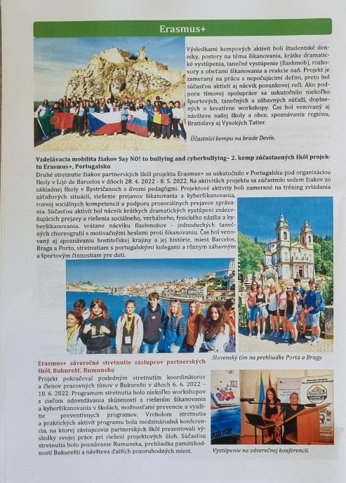
- dissemination: writing an article about the project´s results and Erasmus+ programme in the regional newspapers (June 2022)
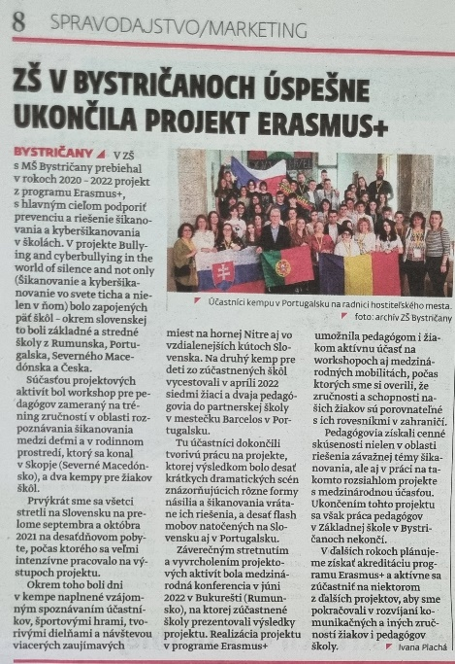
July – August 2022 (Summer holidays for 2 months)
– finalizing the project documents
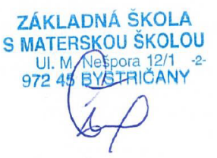
- evaluation of the project impact, results and importance for students, teachers and parents

Mgr. Kamil Šteiner
Headmaster

